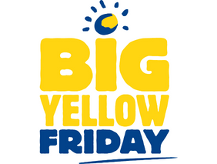

Please support Big Yellow Friday

Dear NAME OF HEAD TEACHER

My child NAME is in class NAME/NUMBER and has NAME OF CONDITION, a rare liver disease. Name is one of the 400 children a year in the UK to be diagnosed with a liver disease but Children’s Liver Disease Foundation (CLDF), now part of the British Liver Trust, has been here for our family since we received this diagnosis, providing information and support, enabling us all to cope with this lifelong condition.
CLDF’s annual awareness day, Big Yellow Friday is on 13th March 2026 and aims to shine a light on these rare childhood diseases.

I would like to ask for your support for Big Yellow Friday 2026. This could be as simple as holding a Wear Yellow Day, bake sale or any kind yellow-themed event. Any money the school can raise would really make a difference to children with liver disease:

- £200 could provide 50 Yellow Alert packs informing health professionals how to spot the early signs of liver disease in babies - life-saving information.

- £500 could fund two virtual information and support sessions enabling young people who may feel isolated by having a rare liver disease to meet others in their situation, get support for their challenges and learn more about how to manage their condition independently.

Please consider holding a fun, yellow event and help make a difference to children like
.
More information can be found at Big Yellow Friday | Children's Liver Disease Foundation including plenty of fundraising ideas and materials.

Please let me know if NAME OF SCHOOL can join in on Friday 13th March and I’ll make sure that Children’s Liver Disease Foundation gives you all the help and materials you need.

Yours sincerely

